**SHIMONI DEMONSTRATION SCHOOL- KIRA**

**MID TERM TWO EXAMINATIONS, 2023**

**BABY CLASS NUMBERS**

**Name ____________________________________________________**

1. Match the same shapes.

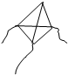

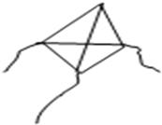

1. Copy and draw.

|  |  |  |
| --- | --- | --- |
|  |  |  |
|  |  |  |

1. Copy and write.

|  |  |  |  |
| --- | --- | --- | --- |
| l | 2 | 3 | 4 |
|  |  |  |  |

1. Match the same numbers.
2. 5
3. 4
4. 1
5. 2
6. 3